Skill-01

Step-1: Open PowerShell as Administrator
- Press Windows.
- Search for PowerShell
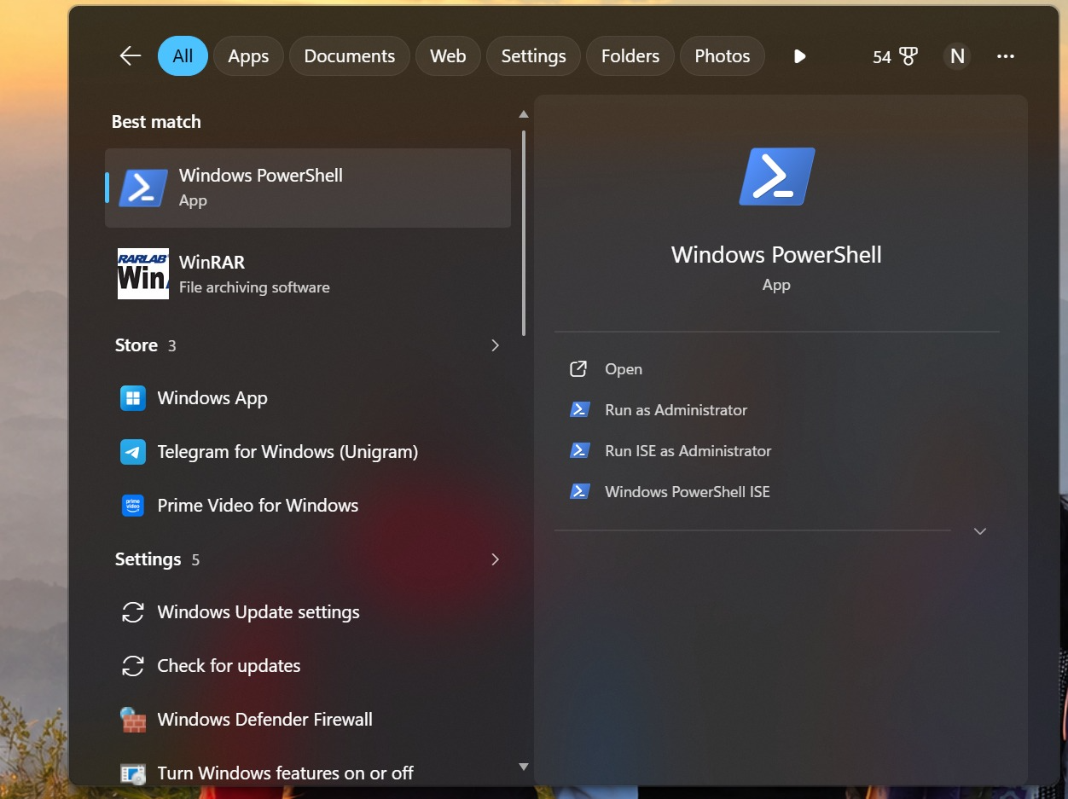

- Click on Run as Administrator
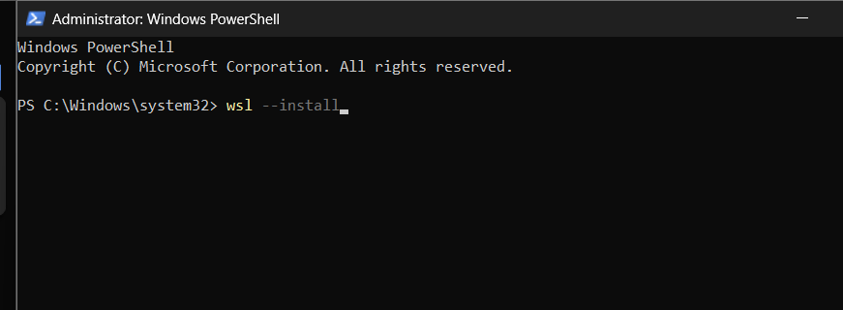

Step 2: Restart Your Computer
After installation, restart your PC when prompted.

Step 3: Complete Ubuntu Setup
After restarting:
- Ubuntu opens automatically (or search for Ubuntu in the Start menu).
- Wait for the installation to finish.
- Create a Linux username
Example: Enter new UNIX username: Samrat

Step 4: Create a Password
You’ll then be prompted to create a password.
New password: ********
Retype new password: ********

Step 5: Update Ubuntu
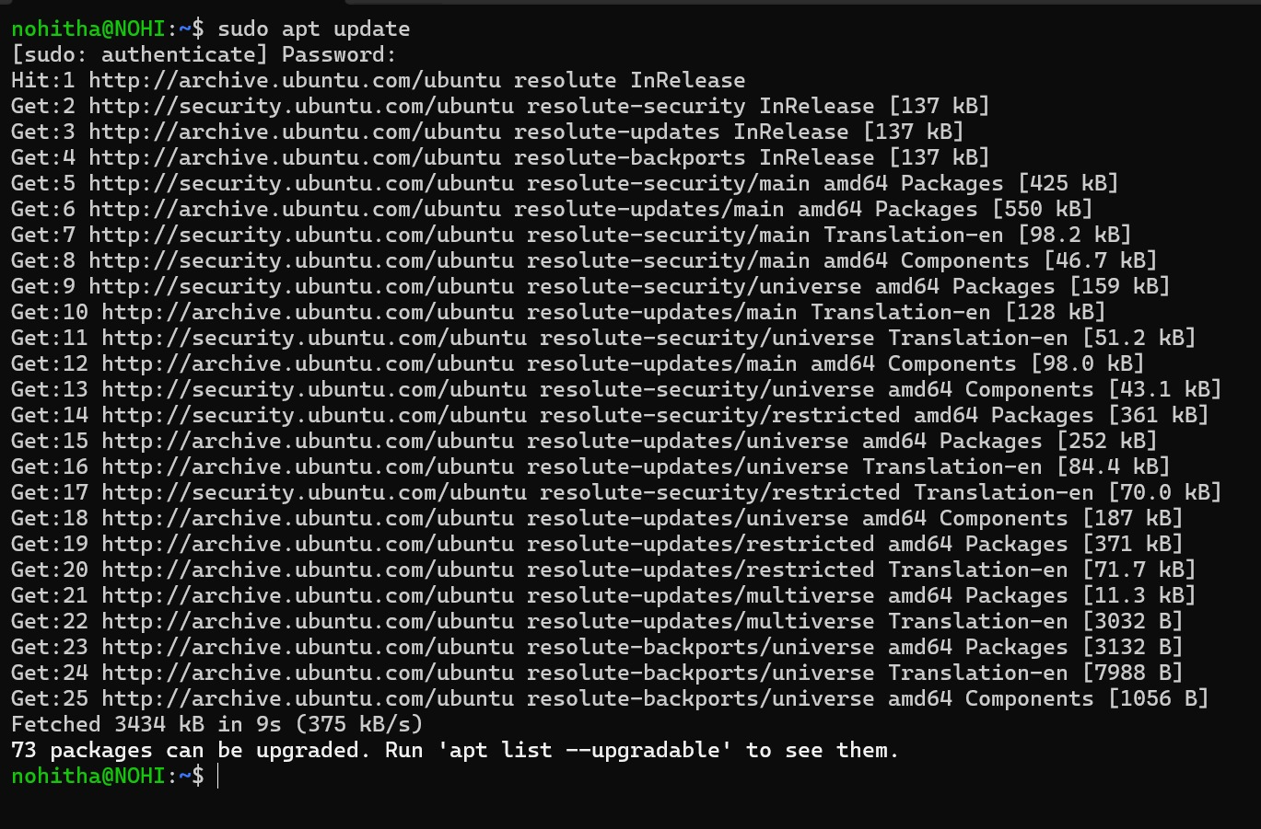

Step 6: Install GCC (C Compiler)
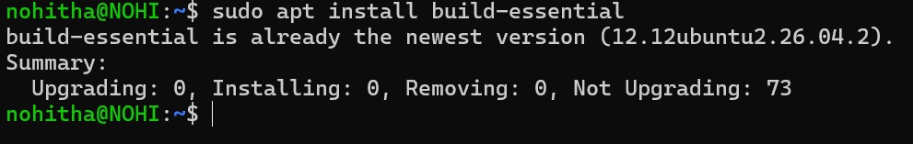

Step 7: Verify the Installation
